PRACTICAL N0:07

Layer 2 Security
a. Assign the Central switch as the root bridge.
b. Secure spanning-tree parameters to prevent STP manipulation attacks.
c. Enable port security to prevent CAM table overflow attacks.

Network:

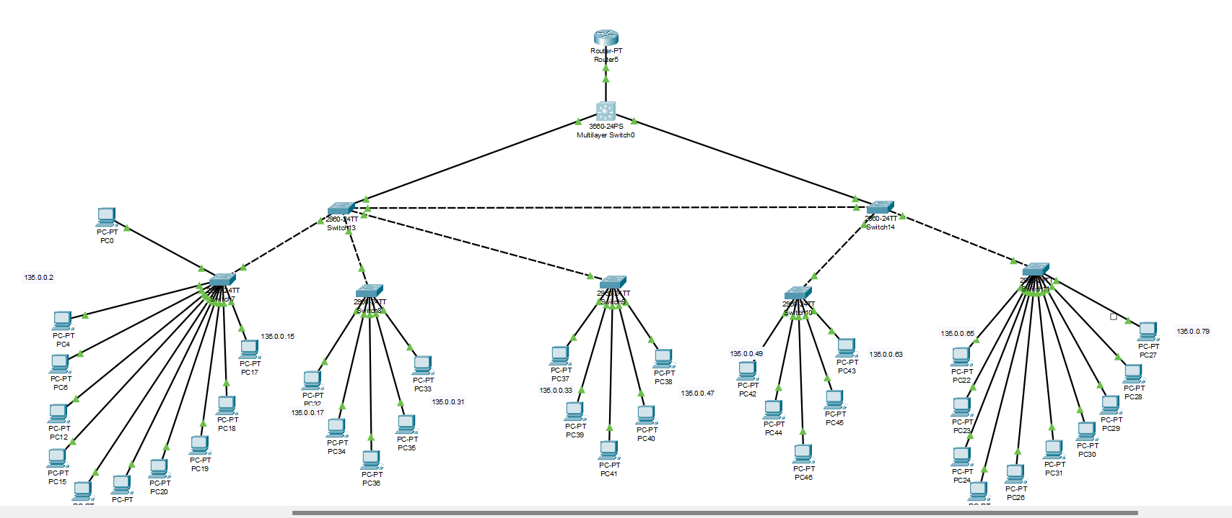

Determine the current root bridge:

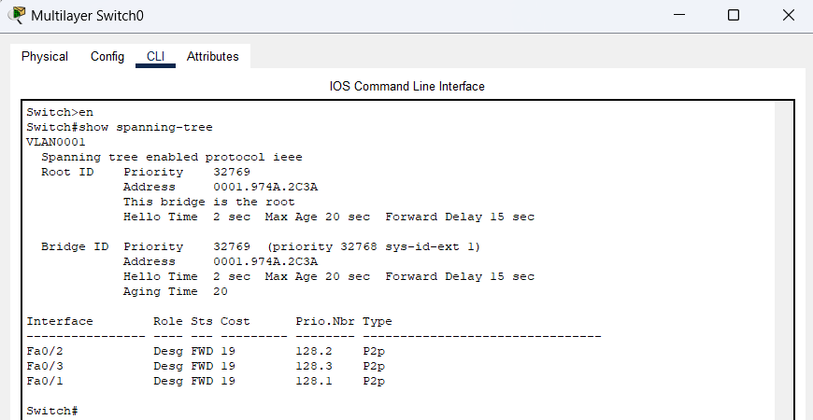

Assign Central as the primary root bridge.

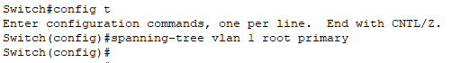

Assign SW-1 as a secondary root bridge.

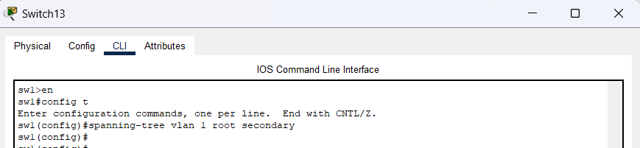

Verify the spanning-tree configuration.

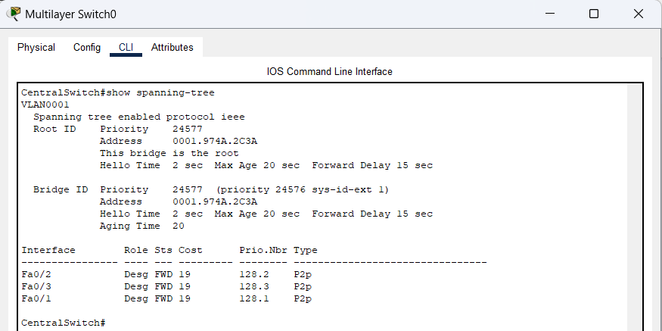

Enable PortFast on all access ports.

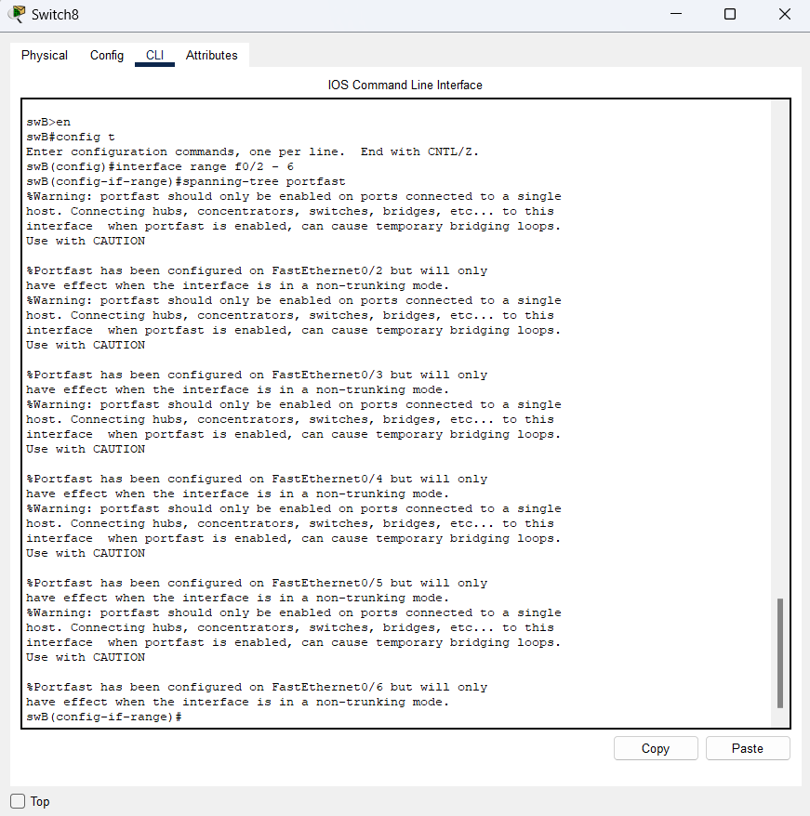

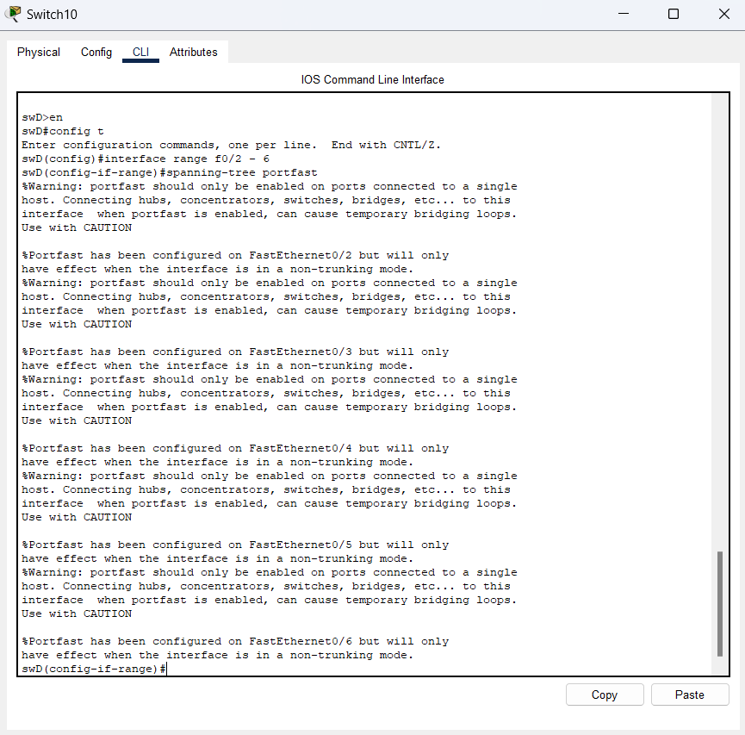

Enable BPDU guard on all access ports.

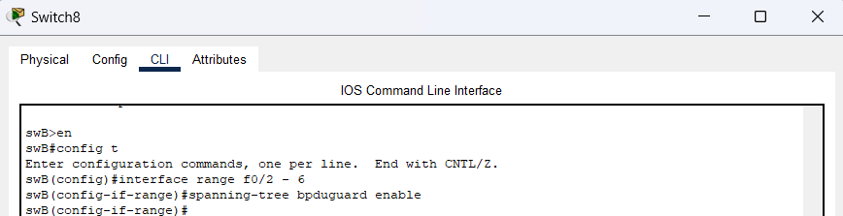

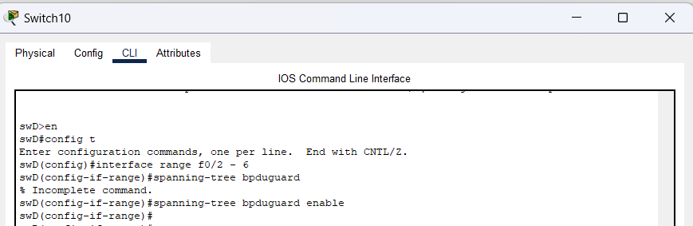

Enable root guard.

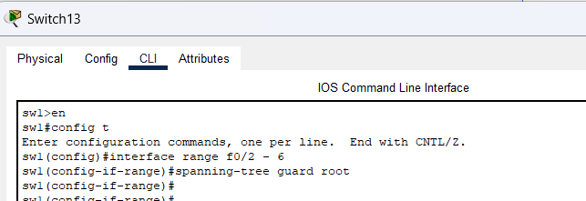

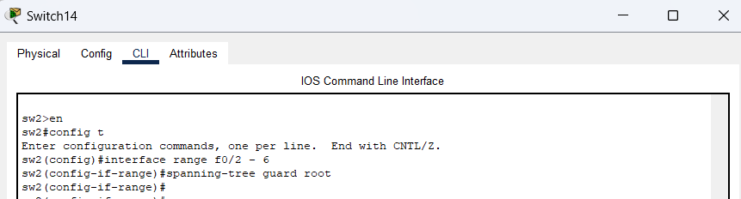

Configure basic port security on all ports connected to host devices.

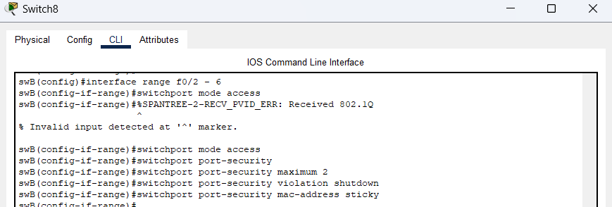

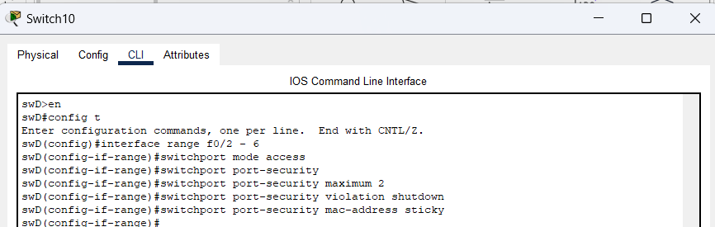

Verify port security.

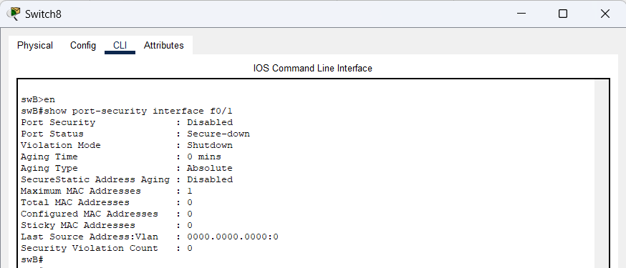

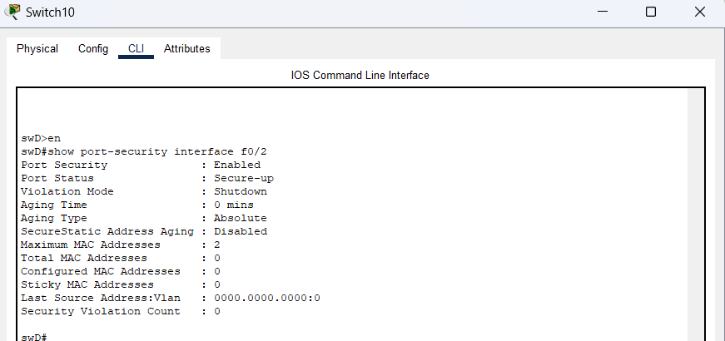

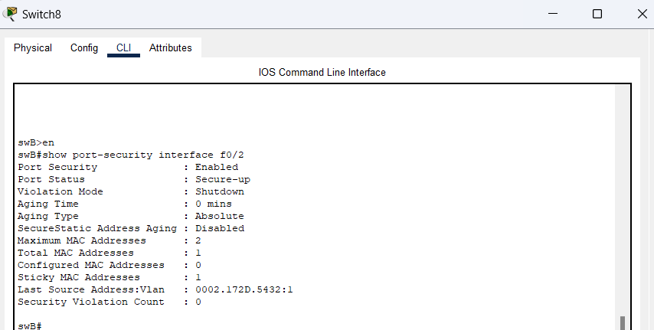

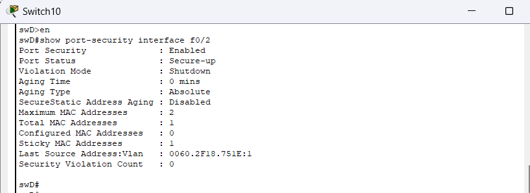

Disable unused ports.

